A tale of two mechanisms: Individual differences in children’s linguistic knowledge predict prime surprisal but not the lexical boost.

The acquisition of verb argument structure poses a potentially difficult problem to the child language learner, who must strike an intimate balance between drawing abstract generalisations and imposing lexical restrictions on verb-structure links. Recent structural priming studies with developmental populations have been particularly revealing regarding potential mechanisms that support acquisition (Rowland, Chang, Ambridge, Pine, & Lieven, 2012; Peter, Chang, Pine, Blything, & Rowland, 2015). In particular, since children are still in the process of acquiring verb-structure links, developmental studies of structural priming are particularly revealing regarding the degree to which structural priming reflects a form of (implicit) learning (Bock & Griffin, 2000; Chang, Dell, & Bock, 2006), and how such learning processes drive development to the adult state. The current study adds to this literature. We report, for the first time, the presence of a lexical boost effect in a developmental population (aged 3 – 8 years), and report developmental differences in the degree to which distributional properties of verbs and the structures they inhabit drive priming via ‘surprisal’, differences which are linked to children current level of linguistic knowledge.
Verb argument structure
Verbs preferentially select for the syntactic environments in which they occur, and both children and adults use this information to make rapid syntactic choices during language processing (e.g., Kidd, Lieven, & Tomasello, 2006; Trueswell, Tanenhaus, & Kello, 1993). In structural priming studies these verb-structure links have been revealing in three significant ways. Firstly, priming effects are often larger when prime and target share the same verb, a phenomenon known as the lexical boost (Pickering & Branigan, 1998). Secondly, the argument structure preference of target verbs modulates priming, such that verbs which are strongly associated with one structure over another resist priming in the dis-preferred structure, but verbs that have no clear bias prime more freely in multiple structures (Coyle & Kaschak, 2008; Gries, 2005). For instance, give, which tends to occur most frequently in the double object (DO) construction (e.g., The man gave the boy a book), is less likely to be primed by a prepositional object dative (e.g., The queen sent a letter to Grandma), whereas a less biased verb like pass primes more freely in both structures. Thirdly, priming tends to be stronger when a prime verb is presented in its dis-preferred structure (e.g., when give is presented in a PO prime), a phenomenon known as prime surprisal (Bernolet & Hartsuiker, 2010; Jaeger & Snider, 2013).
Considerable debate surrounds the extent to whether these three lexical effects on structural priming can be explained by a single mechanism, or whether multiple mechanisms must be invoked (Chang et al., 2006; Pickering & Branigan, 1998). Probabilistic verb-structure links are acquired over the course of development; target verb bias and prime surprisal effects are therefore suggestive of learning. Peter et al. (2015) showed that target verb bias effects increases across development, being a small effect in children aged 3 – 6-years, but considerably larger for adults, suggesting that even by age 6 children may not have fully converged on adult-like verb-structure distributions. Furthermore, they reported that prime surprisal effects are larger in children than in adults. This developmental difference may index implicit learning of structure. Chang et al.’s (2006) connectionist model of sentence production uses error-based learning to drive representational change; when the system makes incorrect structural predictions error-based feedback leads to changes in verb-structure links, a process driven by surprisal. For instance, when the system is predicting a (prime) dative sentence containing the verb give, it will predict a DO structure because this is the most frequent structure for this verb. However, when the prediction is incorrect and the structure is a PO dative, the error-based learning mechanism alters the verb structure links such that the likelihood that a PO dative is produced at target increases. The fact that Peter et al. found this effect to be larger in children is consistent with Chang et al.’s prediction that representational change is greater following erroneous predictions when the system is still acquiring verb-structure links.
While target verb bias and prime surprisal effects are evident in developmental populations, lexical boost effects have not been observed. Both Rowland et al. (2012) and Peter et al. (2015) reported that 3 – 4 year old and 5 – 6 year old children exhibited abstract priming of the dative structure, but no lexical boost in cases where prime and target shared the same verb. These data were interpreted to provide support for Chang et al.’s (2006) suggestion that the lexical boost is attributable to a separate explicit learning mechanism that develops slowly across development. The suggestion is that verb-structure effects in priming have two loci: (i) target verb bias and prime surprisal effects reflect implicit learning of structure, and (ii) lexical boost effects reflect slow-developing explicit memory processes.
The current study
In the current study we provide further evidence for the existence of these two separable mechanisms in priming. Taking an individual differences approach, and focusing on prime surprisal and the lexical boost, we report the existence of both effects in a large sample of 127 English-speaking children aged 4 – 8 years. However, we show that, whereas prime surprisal effects are significantly related to children’s knowledge state as measured by an independent test of language ability, the lexical boost effect was not. We next describe the study and present the results.
Method
Participants
One hundred and twenty-nine (N = 129) children aged between 4;1 and 8;8 were recruited from kindergartens and primary schools in a medium-sized metropolitan Australian city. Two children (one 4 year old and one 7 year old) did not complete the full battery of tests and their data was removed from the final analyses. The mean age of the final sample was 6;2 (SD = 1;2), and the gender distribution was approximately equal (60 females, 67 males). The children were all learning English as a first language, and had no current or past developmental impairment.
Materials & Procedure
The children were tested on a structural priming task and standardized tests of vocabulary and non-verbal IQ. Each test is described in turn.
Structural priming task
Syntactic priming was measured using a modified within-participants version of Rowland et al. (2012). Six alternating dative verbs (gave, passed, threw, showed, sent, and brought) were used. Each verb was used four times; twice in the prime trials and twice in the target trials. Each child therefore completed 12 prime-target trials, 6 of which had verb overlap between prime and target, and 6 of which did not have verb overlap. Half of the primes were presented in a PO structure and half were presented in the DO structure. All NPs were animate, to reduce the possibility that children would use animacy as a cue to structural choice during target scene description. Eight experimental lists were created to balance presentation of verbs across prime and target trials. In the abstract priming condition, each verb was paired with two other verbs across the eight lists (e.g., give was paired with send and pass, and show was paired with bring and throw). Following Rowland et al., 24 filler trials were also used, which were intransitive sentences depicting intransitive events.
The prime-target pairs described 24 animated events, created in Anime Studio Pro. The agents and recipients depicted in the scenes were six pairs of easily recognisable characters, including three pairs of characters with proper noun names (Tigger and Piglet, Dora [the Explorer] and Boots, Bob [the Builder] and Wendy) and three pairs of generic characters labelled with full lexical noun phrases (the prince and the princess, the king and the queen, the girl and the boy). Characters were paired in this way to make it easier for children to create the target sentences. The objects being transferred were all animate objects (a puppy, a cat, a rabbit, a fish, a baby). The animations were controlled for the direction in which the transfer/action occurred (left to right or right to left). An additional 32 cartoons were created to accompany the filler and practice sentences, all describing intransitive actions. Each of the cartoons depicted plausible events. Stimuli were presented on an Apple Macbook Pro with a 13x8 inch screen. Responses to each prime were encoded using Microsoft Excel and also recorded using a Zoom H2 digital recorder in order to check response coding for accuracy.
The children were introduced to the task as a ‘story-telling’ game. They were told that they would take it in turns with the experimenter to describe short cartoon clips played on the computer. The experimenter always went first, which constituted the prime trials. The child then described the target picture; however, following Rowland et al., (2012) the experimenter provided them with the initial NP-V fragment of the sentence (e.g., Dora gave …). This ensured that the dative verb used by children was under experimental control, thereby ensuring that the children used dative verbs in their descriptions of targets, and that there were an equal number of abstract and verb overlap prime-target trials.
Coding
Transcription
Structures….
Vocabulary
Vocabulary was measured using the Peabody Picture Vocabulary Test 2nd edition (PPVT, Dunn & Dunn, 2007). In the task children are required to select the correct picture from an array of four in response to the experimenter’s verbal prompt. The PPVT has excellent psychometric properties (split-half reliability, alpha, and test-retest reliability all > .9). The children’s raw scores were used in the analyses.
Non-verbal IQ
Non-verbal IQ was measured using the Raven’s Coloured Progressive Matrices (Raven, Raven & Court, 1998). In the task children are presented with incomplete visual patterns and are required to complete the pattern by selecting the correct missing piece, from an array of six. Cotton, Kiely, Crewther, Thompson, Laycock and Crewther (2005) report good internal consistency and reliability in a large sample of Australian 6 – 11-year-olds [internal consistency (K-R formula 20) = .89; split half reliability = .90]. The children’s raw scores were used in the analyses.
Results
Logistic mixed effect models were applied to the production of DO structures (DO=1, PD=0) with age, structure, and verb overlap as predictors (all variables centered). Participant was included as a random effect and the maximal model that converged had prime and verb overlap as random slopes. There was a main effect of age, β = 0.31, χ²(1) = 7.1, p < 0.008, which can be seen in the growth of DO production as children get older (Figure X). There was a main effect of structure, β = 1.45, χ²(1) = 51.0, p < 0.001, where DO production was higher after DO primes than after PD primes. There was an interaction of structure and verb overlap, β = 1.37, χ²(1) = 20.3, p < 0.001, where priming was bigger when the verb was the same in prime and target (lexical boost).

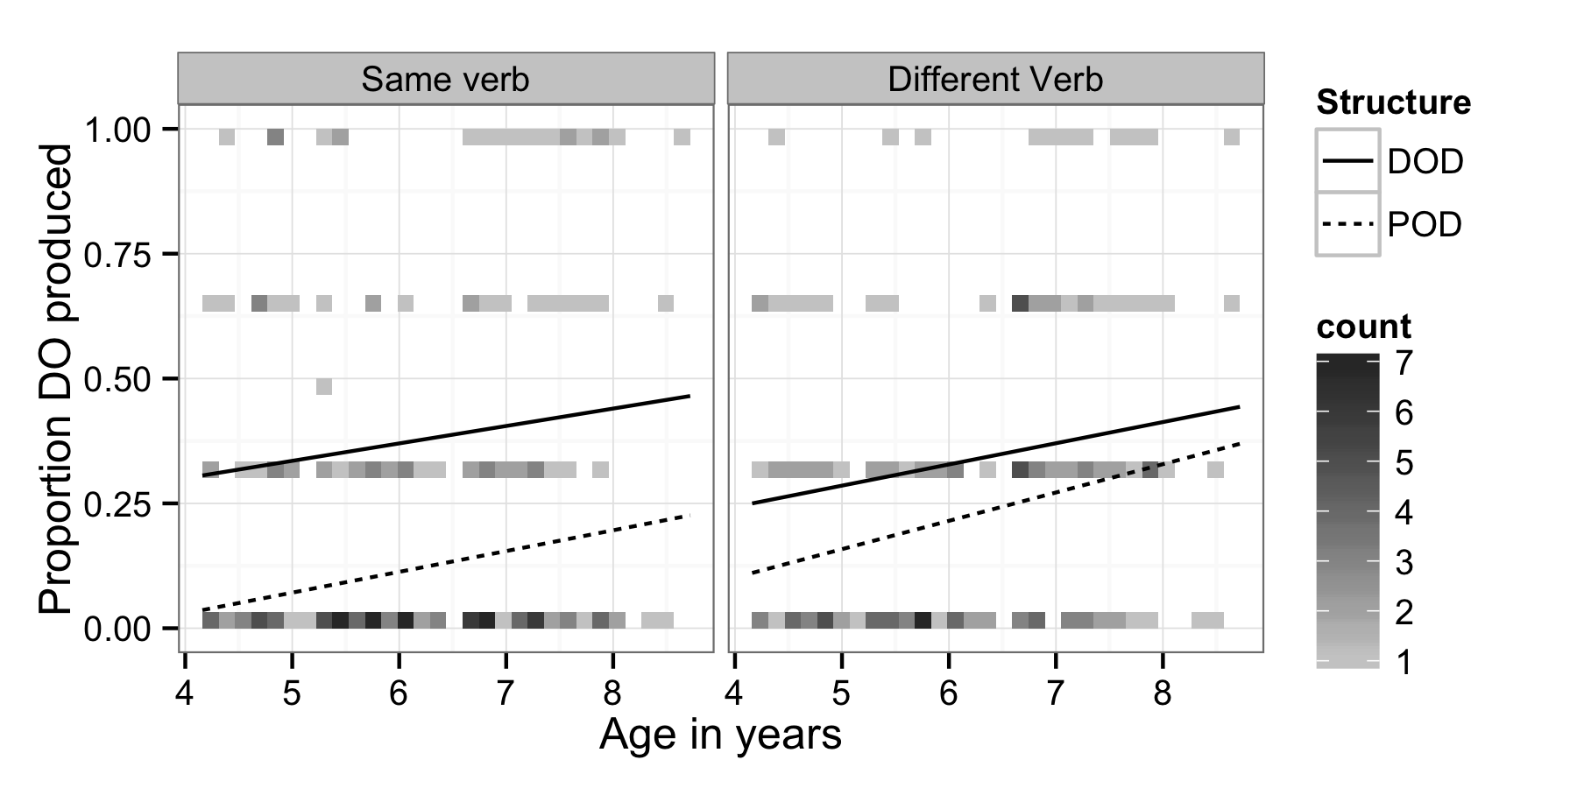
To examine verb-based prime surprisal, we did another analysis using just the different verb condition items. Age, prime structure, and prime verb bias were included as effect coded predictors and participant was a random effect with structure and verb bias crossed as random slopes.
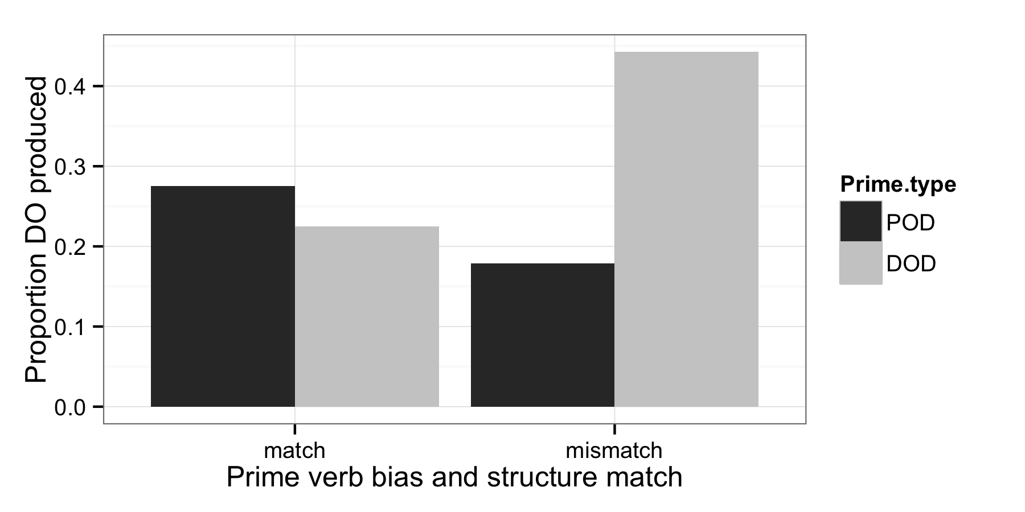
As before, there was a main effect of age, β = 0.35, χ²(1) = 8.7, p < 0.004 and a main effect of structure, β = 0.68, χ²(1) = 7.1, p < 0.008. Critically, there was an interaction of structure and verb bias, β = -2.2, χ²(1) = 16.6, p < 0.001 (Figure X). The negative beta means that when the verb’s bias matched the prime structure, priming was smaller than when the verb’s bias mismatched the structure.
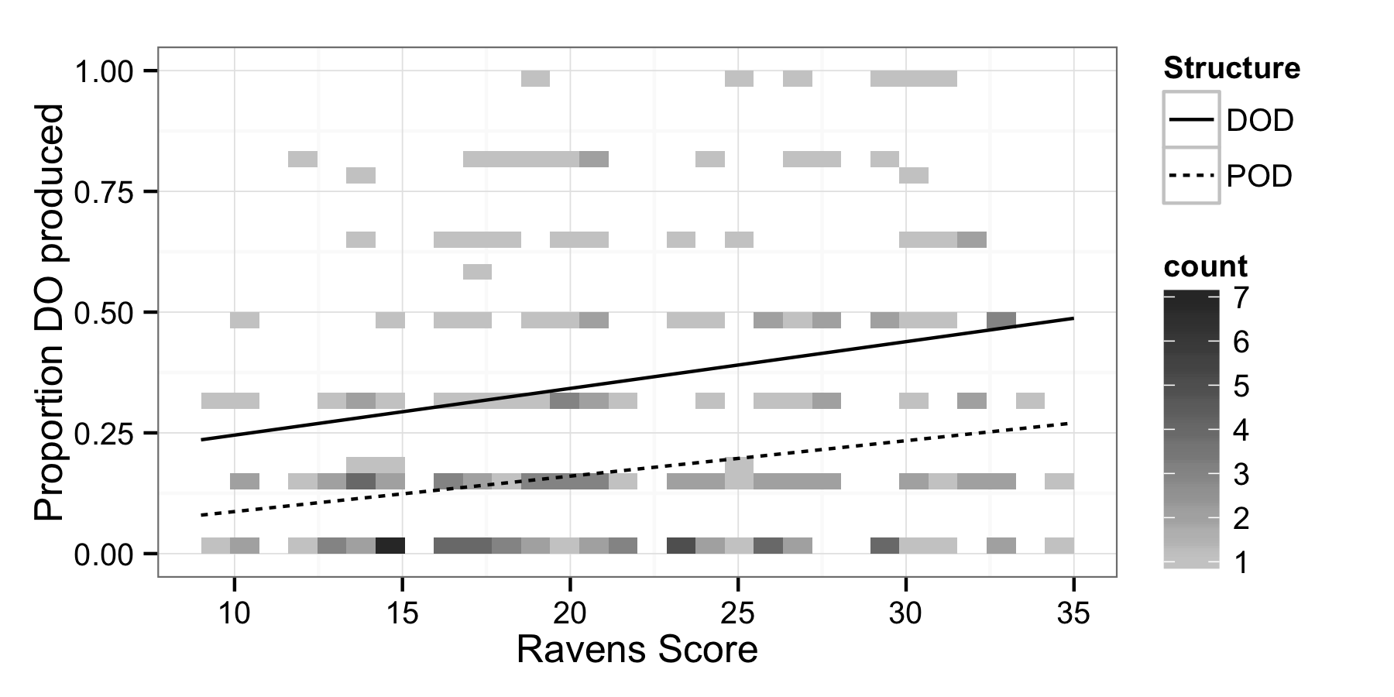To see if the raven’s score influence the lexical boost and abstract priming, we crossed ravens with prime structure and verb overlap (Figure X). There was a main effect of Raven’s score, β = 0.06, χ²(1) = 6.6, p < 0.01. As before, there was a main effect of structure, β = 1.59, χ²(1) = 49.2, p < 0.001 and an interaction with verb overlap, β = 1.71, χ²(1) = 15.3, p < 0.001 (Figure X), but no interactions of priming variables with the Raven’s score.

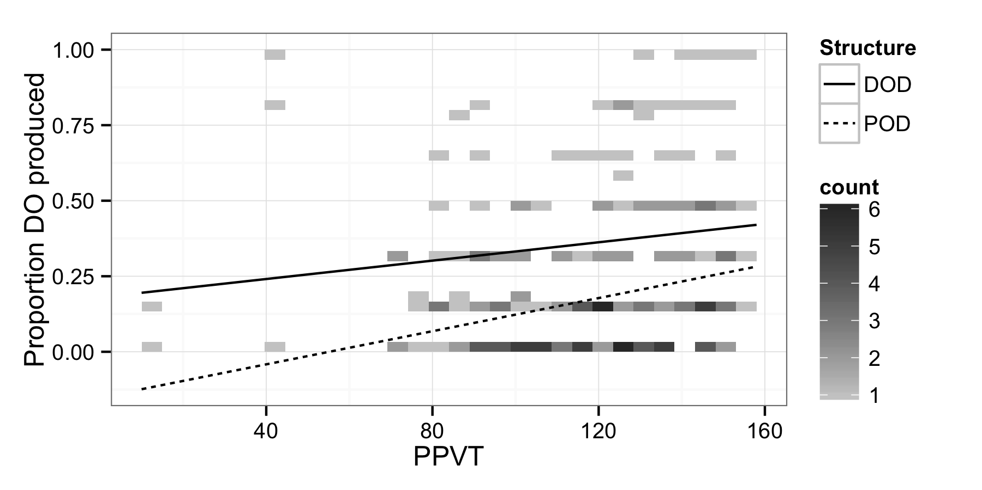
To see if the PPVT score influence the lexical boost and abstract priming, we crossed PPVT with prime structure and verb overlap (Figure X). There was a main effect of PPVT score, β = 0.02, χ²(1) = 7.5, p < 0.01. As before, there was a main effect of structure, β = 1.37, χ²(1) = 83.19, p < 0.001 and an interaction with verb overlap, β = 1.22, χ²(1) = 17.58, p < 0.001 (Figure X). Critically, there was a interaction of PPVT score and priming β = -0.012, χ²(1) = 4.12, p < 0.05 (Figure X).
Discussion

